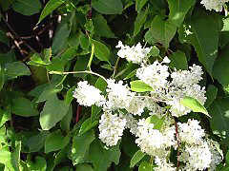

**Sun: full sun; part sun**

**Water: once established drought tolerant**

**Benchcards Found At**

**www.turnersfreshmarket.com**

**Perennial**

***Polygonum aubertti***

**Silver Lace Vine**

* Height: 20-30'
* Fast growing deciduous vine covered with white lacy flowers from late spring through fall
* Only plant in areas where vigorous growth can occur
* Uses: porches, breezeways, fences