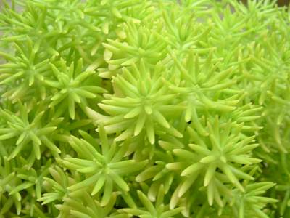

**Sun: full sun**

**Water: dry to medium; drought tolerant**

**Maintenance: Can be pruned at 6-8" to shorten plant (will delay flowering); divide in spring**

|  |  |
| --- | --- |
| **Benchcards Found At**  **www.turnersfreshmarket.com** |  |

**PERENNIAL**

***Sedum***

**Lemon Ball**

* **Zone 3-10; Height 4" Spread 24"**
* **Bright chartreuse mounding/trailing succulent; foliage spills nicely**
* **Uses: spiller over container or raised border edge**