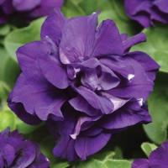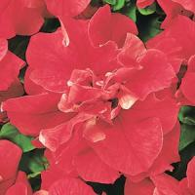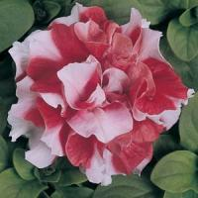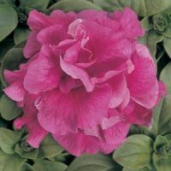

Benchcards Found At
www.turnersfreshmarket.com

ANNUAL
Double Petunia: Madness

Sun: full sun
Water: average; maintain moderately moist soil
Feed: constant feed
Maintenance: Occasional cutback will rejuvenate
- Height: 8-12"; Width: 10-14"

- Attractive double flower

- Uniform & mounding habit; early flowering & floriferous

- Use: Pots, baskets, beds, & landscaping

- Available in: Blue, Red, Red & White, Rose, White

