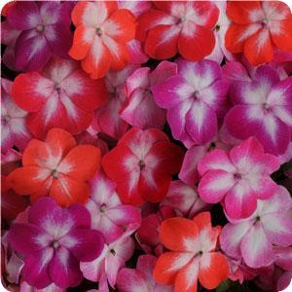

**Sun: shade**

**Water: constant moisture is important**

**Fertilizer: heavy feeder**

**Benchcards Found At**

**www.turnersfreshmarket.com**

**ANNUAL**

**Impatiens: Super**

**Elfin Starburst**

* Height: 8-10"; Width: 12-14”
* Low maintenance
* Produces many flowers
* Uses: shade gardens; bedding plants